Assignment 13 Test Plan

For testing out the back-end of our program, we’ve created a graph that tests out different scenarios for the unweighted shortest path algorithm. The following graph utilizes vertices that have different number of edges as well as multiple paths to another vertex. The first vertex, “1”, will be tested to see if the algorithm can connect the first point to any vertex on the graph.

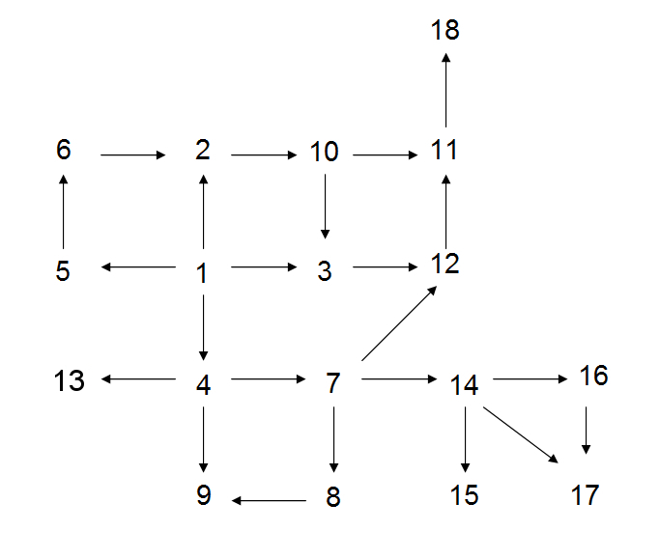

We also tested the front-end segment that utilizes user input from the command line, which can load/unload graphs and let the user pick what vertices to use for the unweighted shortest path algorithm. The front-end will also catch any potential errors that might crash the program (such as vertices that are not indexed, wrong file name, etc.).

Test #1: Unweighted Shortest Path Algorithm

Input | Output (Shortest Path) | Correct Path?
1 to 9 | 1, 4, 9 | Yes
1 to 17 | 1, 4, 7, 14, 17 | Yes
1 to 16 | 1, 4, 7, 14, 16 | Yes
1 to 11 | 1, 2, 10, 11 | Yes
1 to 13 | 1, 4, 13 | Yes
1 to 2 | 1, 3 | Yes
3 to 8 | No path | Yes
4 to 15 | 4, 7, 14, 15 | Yes
13 to 4 | No path | Yes
4 to 18 | 4, 5, 12, 11, 18 | Yes
4 to 9 | 4, 9 | Yes
14 to 17 | 14, 17 | Yes
13 to 13 | 13 | Yes
Test #2: Front End Input Test: Files (Files in test directory: testgraph5.txt, fedex.txt)

Input (text file/clearing) | File exists? | Data inserted?
fedex.txt | Yes | Yes; data inserted
Clear current graph |  | No; data cleared
Notafile.txt | No | No; asks user again
testgraph5.txt | Yes | Yes; data inserted
fedex.txt | Yes | No; another file has already been loaded/no data inserted
Clear current graph |  | No; data cleared
fedex.txt | Yes | Yes; data inserted

Test #3: Front End Input Test: Vertices

Input | Output (Shortest Path) | Correct Path?
0 to 99 | No such vertex; no path | Yes
3 to 3 | 3 | Yes
18 to 4 | No path exists | Yes
-9999 to 9999 | No such vertex; no path | Yes
19 to 0 | No such vertex; no path | Yes
4 to 11 | 4, 7, 12, 11 | Yes

